Paleta de colores

Link: https://coolors.co/7b6b43-6b0504-3a506b-dae3e5-e5f4e3
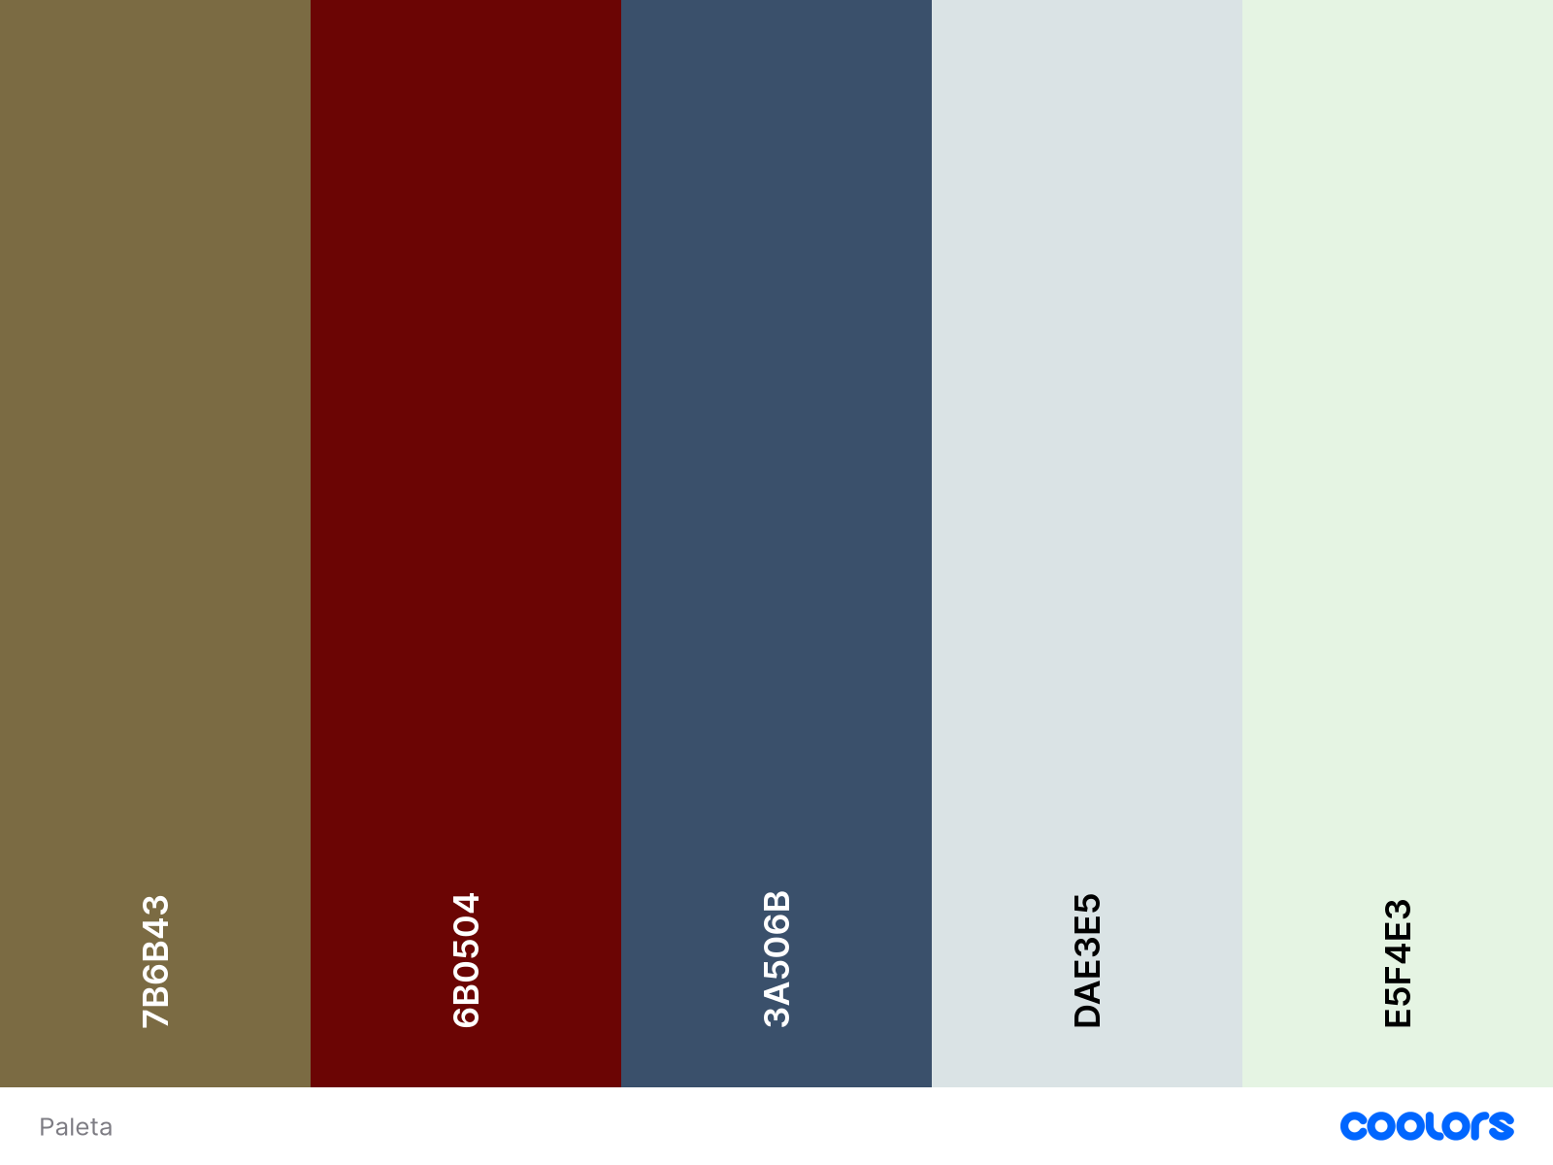

CSS:
/* CSS HEX */
--olive-wood: #7b6b43ff;
--dark-garnet: #6b0504ff;
--dusk-blue: #3a506bff;
--alabaster-grey: #dae3e5ff;
--honeydew: #e5f4e3ff;

/* CSS HSL */
--olive-wood: hsla(43, 29%, 37%, 1);
--dark-garnet: hsla(1, 93%, 22%, 1);
--dusk-blue: hsla(213, 30%, 32%, 1);
--alabaster-grey: hsla(191, 17%, 88%, 1);
--honeydew: hsla(113, 44%, 92%, 1);

/* SCSS HEX */
$olive-wood: #7b6b43ff;
$dark-garnet: #6b0504ff;
$dusk-blue: #3a506bff;
$alabaster-grey: #dae3e5ff;
$honeydew: #e5f4e3ff;

/* SCSS HSL */
$olive-wood: hsla(43, 29%, 37%, 1);
$dark-garnet: hsla(1, 93%, 22%, 1);
$dusk-blue: hsla(213, 30%, 32%, 1);
$alabaster-grey: hsla(191, 17%, 88%, 1);
$honeydew: hsla(113, 44%, 92%, 1);

/* SCSS RGB */
$olive-wood: rgba(123, 107, 67, 1);
$dark-garnet: rgba(107, 5, 4, 1);
$dusk-blue: rgba(58, 80, 107, 1);
$alabaster-grey: rgba(218, 227, 229, 1);
$honeydew: rgba(229, 244, 227, 1);

/* SCSS Gradient */
$gradient-top: linear-gradient(0deg, #7b6b43ff, #6b0504ff, #3a506bff, #dae3e5ff, #e5f4e3ff);
$gradient-right: linear-gradient(90deg, #7b6b43ff, #6b0504ff, #3a506bff, #dae3e5ff, #e5f4e3ff);
$gradient-bottom: linear-gradient(180deg, #7b6b43ff, #6b0504ff, #3a506bff, #dae3e5ff, #e5f4e3ff);
$gradient-left: linear-gradient(270deg, #7b6b43ff, #6b0504ff, #3a506bff, #dae3e5ff, #e5f4e3ff);
$gradient-top-right: linear-gradient(45deg, #7b6b43ff, #6b0504ff, #3a506bff, #dae3e5ff, #e5f4e3ff);
$gradient-bottom-right: linear-gradient(135deg, #7b6b43ff, #6b0504ff, #3a506bff, #dae3e5ff, #e5f4e3ff);
$gradient-top-left: linear-gradient(225deg, #7b6b43ff, #6b0504ff, #3a506bff, #dae3e5ff, #e5f4e3ff);
$gradient-bottom-left: linear-gradient(315deg, #7b6b43ff, #6b0504ff, #3a506bff, #dae3e5ff, #e5f4e3ff);
$gradient-radial: radial-gradient(#7b6b43ff, #6b0504ff, #3a506bff, #dae3e5ff, #e5f4e3ff);

